**ITSE 1330 – Intro to C#**

**Code Test 2 – Module 4 - 6**

**There are 2 projects for this Test. Place both project folders in a folder called FirstnameLastnameCSTest2. When you are done with both projects, zip the folder and submit via Moodle. DO NOT ZIP EACH INDIVIDUAL PROJECT, only the outer folder.**

***Make sure you name your controls and form properly. DO NOT leave the default title on the form. The title for each is included in the specifications.***

*Create a Windows Forms application named* ***FirstNameLastNameTest2A***

*Save the application in the FirstnameLastnameCSModTest2 folder.*

Title:  **Random**

Create an application that generates two random integers, each in the range of 1 through 100.  There should be an initial problem displayed on form load. The numbers should be displayed as addition problems on the application's form, such as:

86 + 23 = ?

The form should have a text box for the user to enter the problem's answer.  When the Generate button is clicked, the application should generate two new random numbers and display them in a new problem on the form. Use Validation to make sure only a number is entered.

When the Check button is clicked, it should check the user's input and display a message indicating whether it is the correct answer or not.

There should be a working Clear and Exit Button as well.

Example Form:

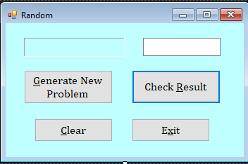

*Create a Windows Forms application named* ***FirstNameLastNameTest2B***

*Save the application in the FirstnameLastnameCSModTest2 folder.*

Title:  **Charge Accounts**

In moodle, under Test2 Resources, you will find a zipped file that contains a text file named ChargeAccounts.txt.  The file contains a list of a company's valid charge account numbers.  **Make sure you unzip the file before trying to use it.**

There is a total of 18 charge account numbers in the file, and each one is a 7-digit number, such as 5658848.

Create an application that reads the contents of the file into an array or a list.  The application should then let the user enter a charge account number.

The program should have a button to determine whether the number is valid by searching for it in the array or list that contains the valid charge account numbers.  Use Validation to make sure only a number is entered and that the entered number is 7 digits.

* If the number is in the array or list, the program should display a message indicating the number is valid.
* If the number is not in the array or list, the program should display a message indicating the number is invalid.

There should be a working Clear and Exit Button as well.

Example Form:

